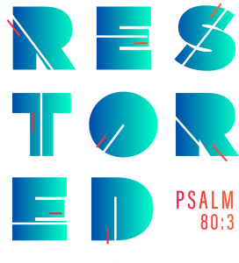
2020 Youth Conference Schedule
Steubenville Northwest
*Times are subject to slight changes*

Friday, July 24
1:00-4:00 – Registration (Hemmingson Center, Gonzaga University)
4:30-6:00 – Dinner (Hemmingson Center)
5:45 – Doors Open - Spokane Convention Center
6:45-9:15 – General Session (to include Keynote “Vision Restored” and Eucharistic Adoration)
9:15-11:00- – Small Groups/Reconciliation/ Marketplace Open

Saturday, July 25
6:45-8:15 – Breakfast (Hemmingson Center for dorm attendees)
7:30 – Doors Open
8:30-10:45 – Morning Session and Celebration of Holy Mass
11:00-2:15 – Marketplace Open
11:00-noon – Women’s Session “Femininity Restored,” Men’s Lunch (Riv Park) and Small Groups
12:15-1:15 – Men’s Session “Masculinity Restored,” Women’s Lunch (Riv Park) and Reconciliation
1:15-2:15 – Men’s Reconciliation, Women’s Small Groups
2:15-3:15 – General Session Keynote “Trust Restored”
3:15-5:15 – Open Time: Recharge
- Small Groups
- Confessions
- Marketplace Open
3:30-4:15 – Workshop “Restore the Conversation: Real Prayer”
4:30-5:15 – Workshop “Restore Peace”
5:15-6:45 – Dinner (Riverfront Park)
5:15-7:15 – Small Groups/Reconciliation/ Marketplace Open
7:15-10:00 – General Session (“Restored in Jesus Christ” and Eucharistic Holy Hour & Procession)
10:00-11:00 – Small Groups/Reconciliation/ Marketplace Open

Sunday, July 26
7:00-8:30 – Breakfast (Hemmingson Center for dorm attendees)
8:00 – Doors Open
9:00-noon – Morning Session “Restore Culture” and Celebration of Holy Mass
10:15-12:00 – Closing Mass

All conference activities (except meals) will take place at the Spokane Convention Center.

