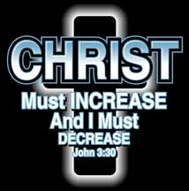
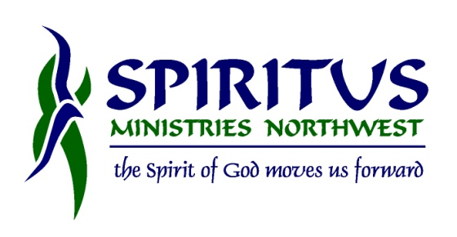
INCREASE 2016

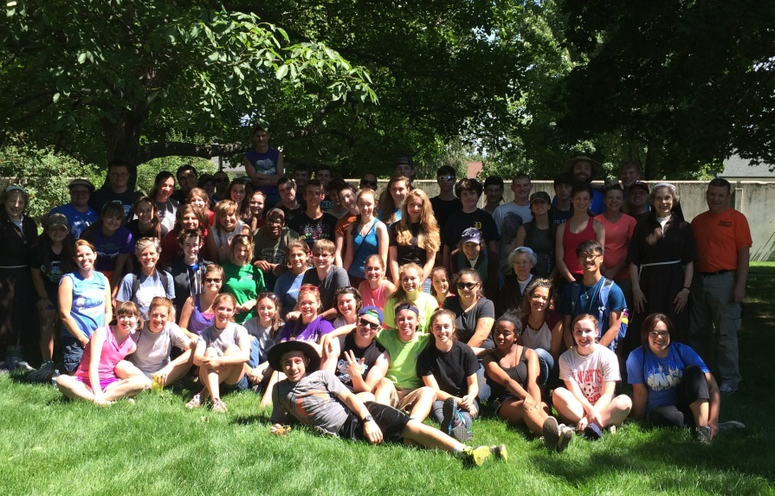
Going to Steubenville Northwest on July 29 – July 31, 2016?
INCREASE is the perfect transition for your youth group from HEARING the message of Jesus Christ to SHARING the message of Jesus Christ. Join other youth groups as they work together to paint, aid those in need of a little extra help around the house, mow some lawns, and experience the JOY of simply serving others.

When: July 31 – August 2, 2016
Where: Spokane, Washington
Cost: $100.00 includes lodging at Gonzaga, meals (breakfast M-T, lunch M-T, dinner Monday)
What to bring: small hand tools, gloves, sunscreen, hat, good attitude, smiles, Bible
Why: To simply serve others so that Christ might INCREASE and we would DECREASE.

Questions? Contact Bob at 360-789-1265 spiritusministries.bob@gmail.com
or Peggy at spiritusministries.peggy@gmail.com 360-789-1000

