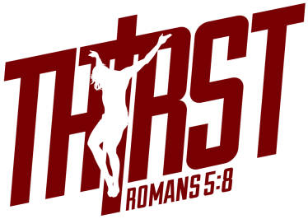
2016 Youth Conference Schedule
Steubenville Northwest
*Times are subject to slight changes.*
Friday
1:30-4:00 – Registration (Gonzaga University – Hemmingson Center Rotunda)
4:30-6:00 – Dinner (Gonzaga University – The COG in Hemmingson Center)
5:45 – Main Venue Doors Open/Marketplace Open
6:45-10:00 – General Session (to include keynote and Eucharistic Adoration)
10:00-11:15 – Small Groups/Reconciliation/ Marketplace Open

Saturday
6:30-8:00 – Breakfast (The COG in Hemmingson Center)
7:30 – Main Venue Doors Open
8:30-10:45 – General Session (to include Saturday daily Mass)
11:15-12:15 – Men’s/Women’s Sessions
12:15 – Lunch
12:45-2:30 - Small Groups/Reconciliation/ Marketplace Open
1:00-1:45 – Workshop for Seniors & Graduated Seniors (Room 100A)
2:30-3:15 – Round of Workshops
3:45-4:30 – Round of Workshops
4:30-6:30 – Small Groups/Reconciliation/Marketplace Open
4:45 – Dinner
6:45-9:45 – General Session (to include keynote and Eucharistic Holy Hour & Procession)
9:45-11:15 – Small Groups/Reconciliation/ Marketplace Open

Sunday
6:30-8:00 – Breakfast (The COG)/Key Return (Hemmingson Center)
7:30 – Main Venue Doors Open
8:30-10:30 – General Session (to include keynote)
10:30-12:00 – Closing Mass
12:00 – Pre-Ordered Lunch-to-Go (if ordered)
12:00-1:30 – Key Return (Hemmingson Center)

